
CENTRAL WEST EDUCATION DIVISION
2026 MALAWI SCHOOL CERTIFICATE OF EDUCATION MOCK EXAMINATION

PHYSICS
Subject Number: M164/I
Thursday, 23 March Time Allowed: 2 hours
08:00 – 10:00 am

PAPER I
(100 marks)
Instructions
Question Number | Tick if answered | Do not write in these columns
1
2
3
4
5
6
7
8
9
10
11
12
13
- This paper contains 10 printed pages. Please check.

- Answer all the thirteen questions in this paper.
- The maximum number of marks for each answer is indicated against each question.
- Write your answers in the spaces provided on the question paper.
- All working must be clearly shown
- Write your Examination number and School (Day/ODL) at the top of each page of your question paper.
- In the table provided on the page, tick against the question number you have answered

©2025 CWED MOCK Turn over

SECTION A (70 marks)
Answer all questions.

1. a. The actual length of a rod is 10cm. if a student measured 9.85cm.
(i) Identify the type of error from the statement.
________________________________________________________________ 1 mark
(ii) Calculate the relative error.

3 marks
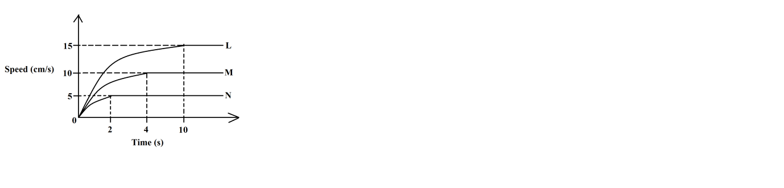
b. Figure 1 shows two identical objects falling through three different liquids L, M and N.

Figure 1

(i) Identify the liquid in which the object reaches the bottom first.
________________________________________________________________ 1 mark.
(ii) Describe the motion of the object in liquid M.
_____________________________________________________________________________________________________________________________________ 2 marks
2. a. Define momentum.
_______________________________________________________________________________________________________________________________________ 1 mark
b. Table 1 shows the coefficient of sliding friction between surfaces P and Q, R and S.
Table 1
Surface | Reaction (N) | Coefficient of Friction
P and Q | 25 | 0.56
R and S | 25 | 0.62

(i) Which pair of surface require more force to start motion.
_________________________________________________________________ 1 mark
(ii) If the limiting force between P and Q is 37N, Calculate the coefficient of friction for the same reaction force.

3 marks
c. Give two differences between elastic and inelastic collision.
_________________________________________________________________________________________________________________________________________________________________________________________________________________________________________________________________________________________ 2 marks
3. a. Give any one characteristic of a vibrating system.
________________________________________________________________ 1 mark
b. Figure 2 shows a displacement-time graph of a vibrating system.
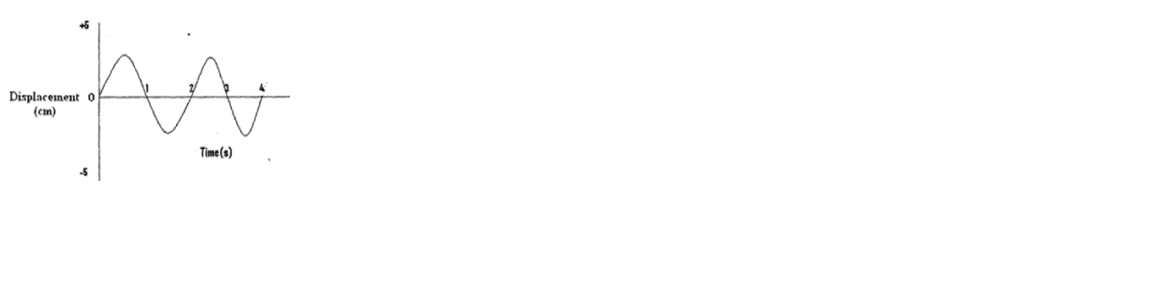

Figure 2
(i) State the meaning of the + and – signs respectively below and above the 0 sign.
________________________________________________________________ 1 mark
(ii) Calculate the wavelength of the wave if it vibrates a distance of 10m.

3 marks
(iii) Explain why these vibrations would eventually stop after some time.
_____________________________________________________________________________________________________________________________________ 2 marks
4. a. State Lenz’s law.
_________________________________________________________________ 1 mark
b. Mention any two factors that affect the magnitude of induced emf.
_______________________________________________________________________________________________________________________________________ 2 marks
c. Explain any two environmental impact of hydro power generation.
_______________________________________________________________________________________________________________________________________ 2 marks
d. Draw a resistor of a resistance 40×10⁴±10% or 400,000±10% using colour codes.

2 marks
5. a. Give any three effects of atmospheric pressure.
_____________________________________________________________________________________________________________________________________________________________________________________________________________________________________________________________________________________ 3 marks
b. Calculate the density of a liquid in which 27cm³ of the liquid exerts a pressure of 900 Pa at the bottom of a jar whose cross-section area is 3cm³?

4 marks
6. a. Table 2 shows characteristics of radioactive samples.
Table 2
Sample | Effect on gold leaf electroscope | Effect on card board
A | No effect | Pass through
B | Discharged | Blocked

(i) Identify the particles emitted by samples A and B.
A ______________________________________________________________ 1 mark
B ______________________________________________________________ 1 mark
(ii) Explain why the particle emitted by sample B are easily blocked by the cardboard.
_________________________________________________________________________________________________________________________________________________________________________________________________________________________________________________________________________________ 2 marks
b. The initial count rate of a certain radio isotope is 80 counts per minute. if after 24 hours the count rate reduces to 5 counts per minute. Calculate the half-life for this isotope.

3 marks
7. a. Why is a body moving in a uniform circular motion said to accelerate despite moving at a constant speed?
_______________________________________________________________________________________________________________________________________ 1 mark
b. A toy car of mass 6 kg moving at 12 m/s collides with a stationary truck of mass 20 kg. If they move together, find their common velocity.

3 marks
c. Describe green house effect in relation to electromagnetic waves.
_____________________________________________________________________________________________________________________________________________________________________________________________________________________________________________________________________________________________________________________________________________________________________________________________________________________________ 3 marks
8. a. Figure 3 is an electric circuit diagram.
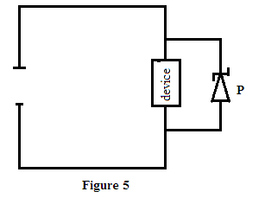

Figure 3
(i) Identify component labelled P.
_______________________________________________________________ 1 mark
(ii) Describe how component labelled P works.
_________________________________________________________________________________________________________________________________________________________________________________________________________ 3 marks
b. Give any three reasons why the efficiency of a transformer is less than 100%.
____________________________________________________________________________________________________________________________________________________________________________________________________________________________________________________________________________________________________________________________________________________________ 2 marks
9. a. Figure 4 shows arrangement of particles in three states of matter.
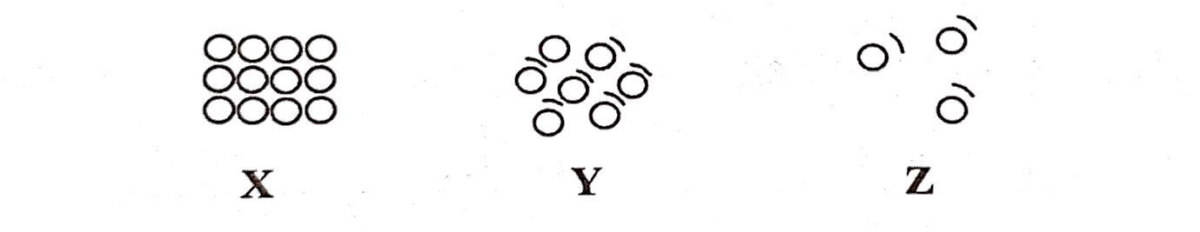

Figure 4
(i) Identify the state of matter in which sound travels faster.
_______________________________________________________________ 1 mark
(ii) Give a reason for the answer in 9. a. (i).
___________________________________________________________________________________________________________________________________ 2 marks
b. Explain any one difference between real and virtual image formed by a convex lens.
________________________________________________________________ 1 mark
c. An object is placed 15cm away from a convex lens of focal length 10cm. Calculate the
image distance.

3 marks

10. a. Mention any one factor that affect loudness of sound.
_________________________________________________________________ 1 mark
b. Figure 5 is a velocity-time graph for the motion of a body of mass 2kg.
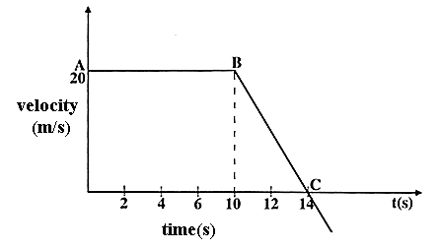

Figure 5
(i) Describe the motion of the body from A to B.
_____________________________________________________________ 1 mark
(ii) Calculate the distance covered by the body between B and C.

3 marks
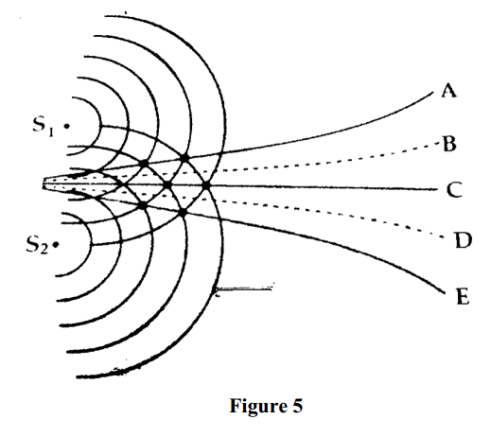
c. Figure 6 shows sources of water waves S₁ and S₂ generating continuous circular waves.

Figure 6
(i) Identify the lines presenting destructive interference.
____________________________________________________________ 1 mark
(ii) Explain why the points along line C experiences maximum displacement.
_________________________________________________________________________________________________________________________________________________________________________________________________________________________________________________________________ 2 marks

SECTION B (30 marks)
11. a. Describe how a centre of mass of a regular L-shaped paper can be determined.
__________________________________________________________________________________________________________________________________________________________________________________________________________________________________________________________________________________________________________________________________________________________________________________________________________________________________________________________________________________________________________ 5 marks
b. Describe how a hydraulic machine works.
__________________________________________________________________________________________________________________________________________________________________________________________________________________________________________________________________________________________________________________________________________________________________________________________________________________________________________________________________________________________________________ 5 marks
12. a. Describe how atmospheric pressure can be determined using a collapsing can
experiment.
__________________________________________________________________________________________________________________________________________________________________________________________________________________________________________________________________________________________________________________________________________________________________________________________________________________________________________________________________________________________________________ 5 marks
b. Describe how a u-tube manometer can be used to measure lung pressure.
___________________________________________________________________________________________________________________________________________________________________________________________________________________________________________________________________________________________________________________________________________________________________________________________________________________________________ 5 marks
13. a. With the aid of a well labelled diagram describe how a light operated switch works in order to give light during the night.

___________________________________________________________________________________________________________________________________________________________________________________________________________________________________________________________________________________________________________________________________________________________________________________________________________________________________ 6 marks
b. Explain the relationship between decrease in temperature and molecular motion.
___________________________________________________________________________________________________________________________________________________________________________________________________________________________________________________________________________________________________________________________________________________________________________________________________________________________________ 4 marks
END OF QUESTION PAPER
NB: This paper contains 10 printed pages.

